**NAME: CHIRANJEEVI NERELLA DEPT: DATA SCIENCE**

**UNT ID: 11442777 DATE: 07/03/2021**

**ASSIGNMENT: 3 COURSE: INFO 5502**

1)

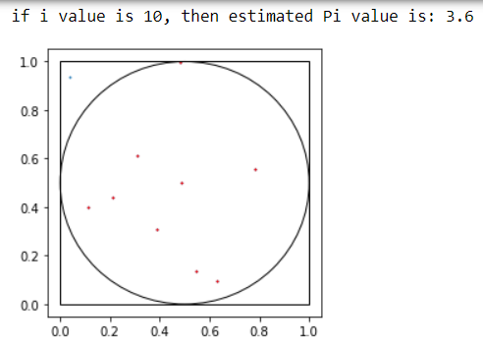

2)

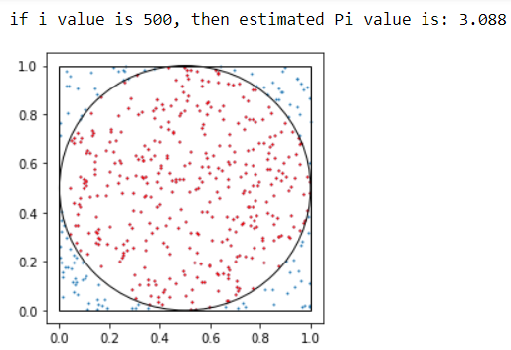

3)

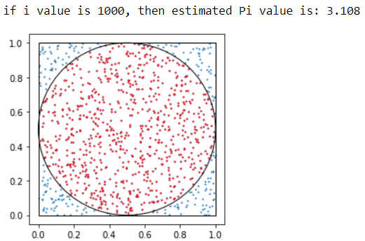

4)

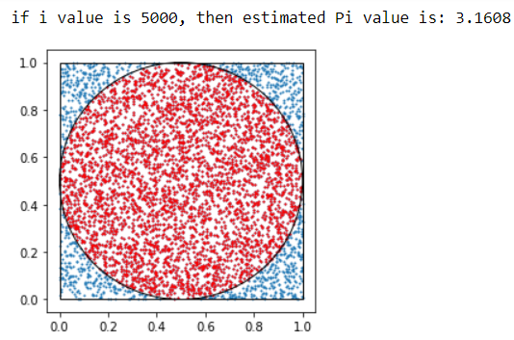

5)

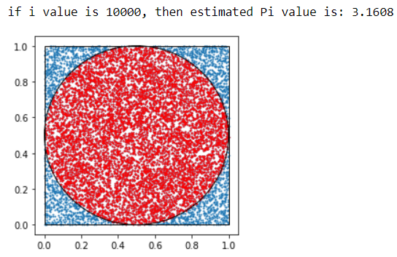

6)

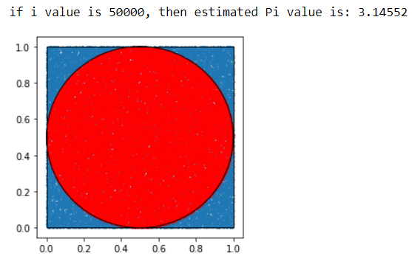

7)

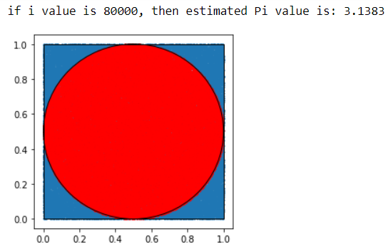

8)

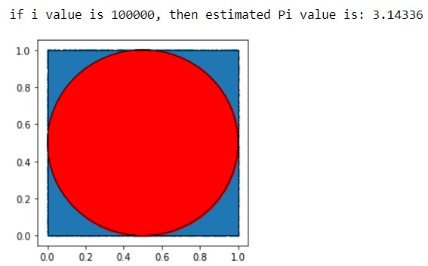

9)

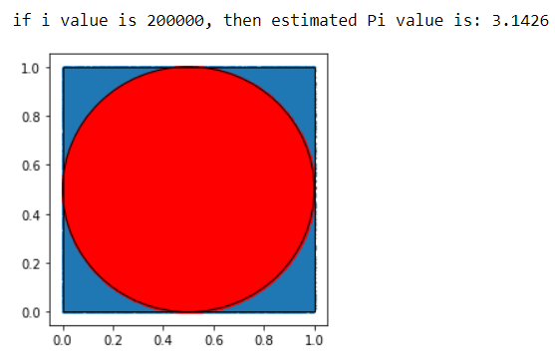

10)

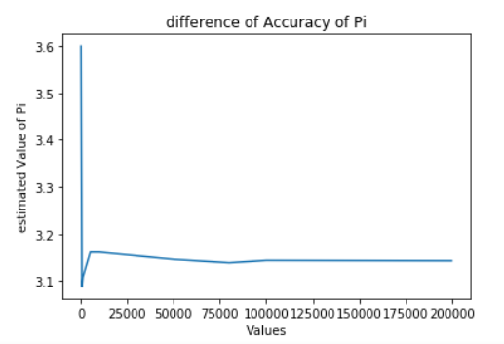

**Generated pi values for different values of ‘i’ the above line graph is plotted with Values of i and estimated Pi values being the x & y axis**